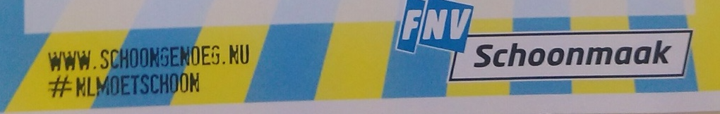

Message of Solidarity to the Striking Cleaners at Paris-Nord Station

We, members of the FNV Domestic Workers Union in the Netherlands, extend our solidarity to our brothers and sisters employed as cleaners of train stations in Paris who have been on strike since November 1, 2017. They are protesting against an anti-worker "mobility clause" in a new contract signed by SCNF with a new employer firm. Such "mobility clause" only means making it easier for the capitalist to fire their workers because unwanted workers can be assigned in far off locations and if they refuse or complain this can be used by the capitalist to fire them. The employees are also demanding an increase in their meal allowance, the retention of staff under the new employer firm and revaluation of their holiday bonus.

These are very legitimate demands because the new employer firm, H. Reinier, is a subsidiary of the Onet group which in 2016 had a turnover of 1.8 billion euros. Instead of listening to these very reasonable demands SNCF summoned 9 employees to dismiss them presumably as a warning to the other cleaners. But the cleaners have fought back with a strike reiterating their demands and calling on ONET and SNCF to drop their prosecution of their 9 colleagues.

This case of the train station cleaners in Paris is just an example of the so-called labor reforms of the new French president Macron who is shamelessly pro-capitalist and anti-worker. One of the main planks of his "reform" is to make it easier for capitalists to fire workers.

There is a trend in Europe for governments to take away the rights and benefits that the workers movement has won in the past through hard struggle. It is important that all workers must unite to fight against these attacks on their rights and livelihood.

Support the just demands of the employees of H. Reinier!
Long live international solidarity of the working people!

FNV Schoonmaak en Migrant Domestic Workers
www.schoongenoeg.nu

